How to Login to 1st Otto-mation
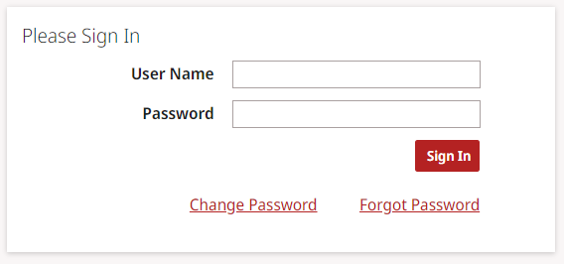
Each agent will be assigned their own unique username. The username is 6 digits long and the first 4 digits should be your agencies assigned 1st Auto contract number.
Enter your password. If you do not remember your password, click on Forgot Password. You should be prompted to enter your username and request a temporary password. This temporary password will be sent to you via email.
Click on Change Password
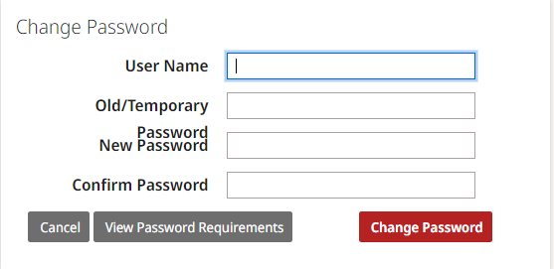
Enter your username and the temporary password that was emailed to you. Enter and confirm a new password using the following guidelines:
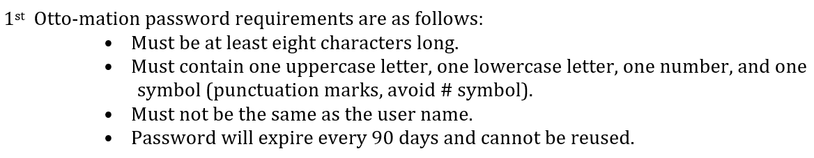
Click Change Password. If successful you should receive the below message:
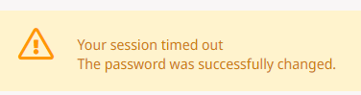
Enter your Username and your new password to proceed into 1st Otto-mation.
If any questions, please contact our office.

